Name:- Saniya Mallick

Enroll no:- ADT23SOCB1554

DA-1

ROLL NO.:- 12

ASSIGNMENT WP

Code:- products.html html and javascript together

<!DOCTYPE html>

<html lang="en">

<head>

<meta charset="UTF-8">

<meta name="viewport" content="width=device-width, initial-scale=1">

<title>Artwave | Recommendations</title>

<link rel="stylesheet" href="style.css">

<style>

.container {

max-width: 1200px;

margin: 0 auto;

padding: 0 15px;

}

.product-grid {

display: grid;

grid-template-columns: repeat(2, 1fr);

gap: 20px;

margin-bottom: 30px;

}

.product-card {

background: #351A39;

border: 1px solid #3c2b38;

border-radius: 8px;

padding: 10px;

text-align: center;

box-shadow: 0 2px 5px rgba(0, 0, 0, 0.2);

transition: transform 0.3s ease;

}

.product-card:hover {

transform: translateY(-5px);

}

.product-card img {

width: 100%;

height: auto;

border-radius: 4px;

}

.price {

font-weight: bold;

margin: 10px 0;

}

.btn {

display: inline-block;

padding: 8px 16px;

background: #C89D65;

color: #351A39;

text-decoration: none;

border-radius: 4px;

transition: background 0.3s ease;

}

.btn:hover {

background: #B3875D;

}

</style>

</head>

<body>

<header>

<div class="container header-container">

<div class="logo">Artwave</div>

<nav>

<ul>

<li><a href="index.html">Home</a></li>

<li><a href="products.html">Recommendations</a></li>

<li><a href="player.html">Mood Player</a></li>

<li><a href="cart.html">Cart</a></li>

<li><a href="about.html">About Us</a></li>

<li><a href="contact.html">Contact</a></li>

<li><a href="login.html">Login</a></li>

<li><a href="register.html">Register</a></li>

</ul>

</nav>

</div>

</header>

<section class="products">

<div class="container">

<h2>Our Recommendations</h2>

<div class="product-grid">

<div class="product-card">

<img src="https://images.unsplash.com/photo-1491609154219-ffd3ffafd992?w=1200&auto=format&fit=crop&q=60" alt="Energetic Playlist">

<h4>Energetic Playlist</h4>

<p>Perfect tunes to get you moving.</p>

<p class="price">$49.99</p>

<a href="#" class="btn add-to-cart">Add to Cart</a>

</div>

<div class="product-card">

<img src="https://plus.unsplash.com/premium_photo-1663953665864-d5ca6e0c4c4d?w=1200&auto=format&fit=crop&q=60" alt="Calm Vibes">

<h4>Calm Vibes</h4>

<p>Relax with soothing melodies.</p>

<p class="price">$29.99</p>

<a href="#" class="btn add-to-cart">Add to Cart</a>

</div>

</div>

<div class="product-grid">

<div class="product-card">

<img src="https://plus.unsplash.com/premium_photo-1669665827401-30f37a4411f0?w=1200&auto=format&fit=crop&q=60" alt="Abstract Expression">

<h4>Abstract Expression</h4>

<p>Art that inspires creativity.</p>

<p class="price">$39.99</p>

<a href="#" class="btn add-to-cart">Add to Cart</a>

</div>

<div class="product-card">

<img src="https://plus.unsplash.com/premium_photo-1682308262087-a19aa679649d?w=1200&auto=format&fit=crop&q=60&ixlib=rb-4.0.3&ixid=M3wxMjA3fDB8MHxzZWFyY2h8MXx8bW9kZXJuJTIwYXJ0fGVufDB8MHwwfHx8MA%3D%3D" alt="Modern Art">

<h4>Modern Art</h4>

<p>Bold visuals for your space.</p>

<p class="price">$59.99</p>

<a href="#" class="btn add-to-cart">Add to Cart</a>

</div>

</div>

</div>

</section>

<footer>

<div class="container footer-content">

<p>&copy; 2025 Artwave. All Rights Reserved.</p>

<ul class="footer-links">

<li><a href="contact.html">Privacy Policy</a></li>

<li><a href="contact.html">Terms of Service</a></li>

</ul>

</div>

</footer>

<script>

document.addEventListener('DOMContentLoaded', function() {

const buttons = document.querySelectorAll('.add-to-cart');

buttons.forEach(function(button) {

button.addEventListener('click', function(e) {

e.preventDefault();

const card = e.target.closest('.product-card');

if (!card) return;

const title = card.querySelector('h4').textContent;

const description = card.querySelector('p').textContent;

const imageUrl = card.querySelector('img').src;

const priceText = card.querySelector('.price').textContent.replace('$', '');

const price = parseFloat(priceText);

const product = { title, description, imageUrl, price, qty: 1 };

let cart = JSON.parse(localStorage.getItem('cartItems')) || [];

const existingProduct = cart.find(item => item.title === product.title);

if (existingProduct) {

existingProduct.qty += 1;

} else {

cart.push(product);

}

localStorage.setItem('cartItems', JSON.stringify(cart));

alert(`${title} has been added to your cart!`);

});

});

});

</script>

</body>

</html>

Product page code output:-

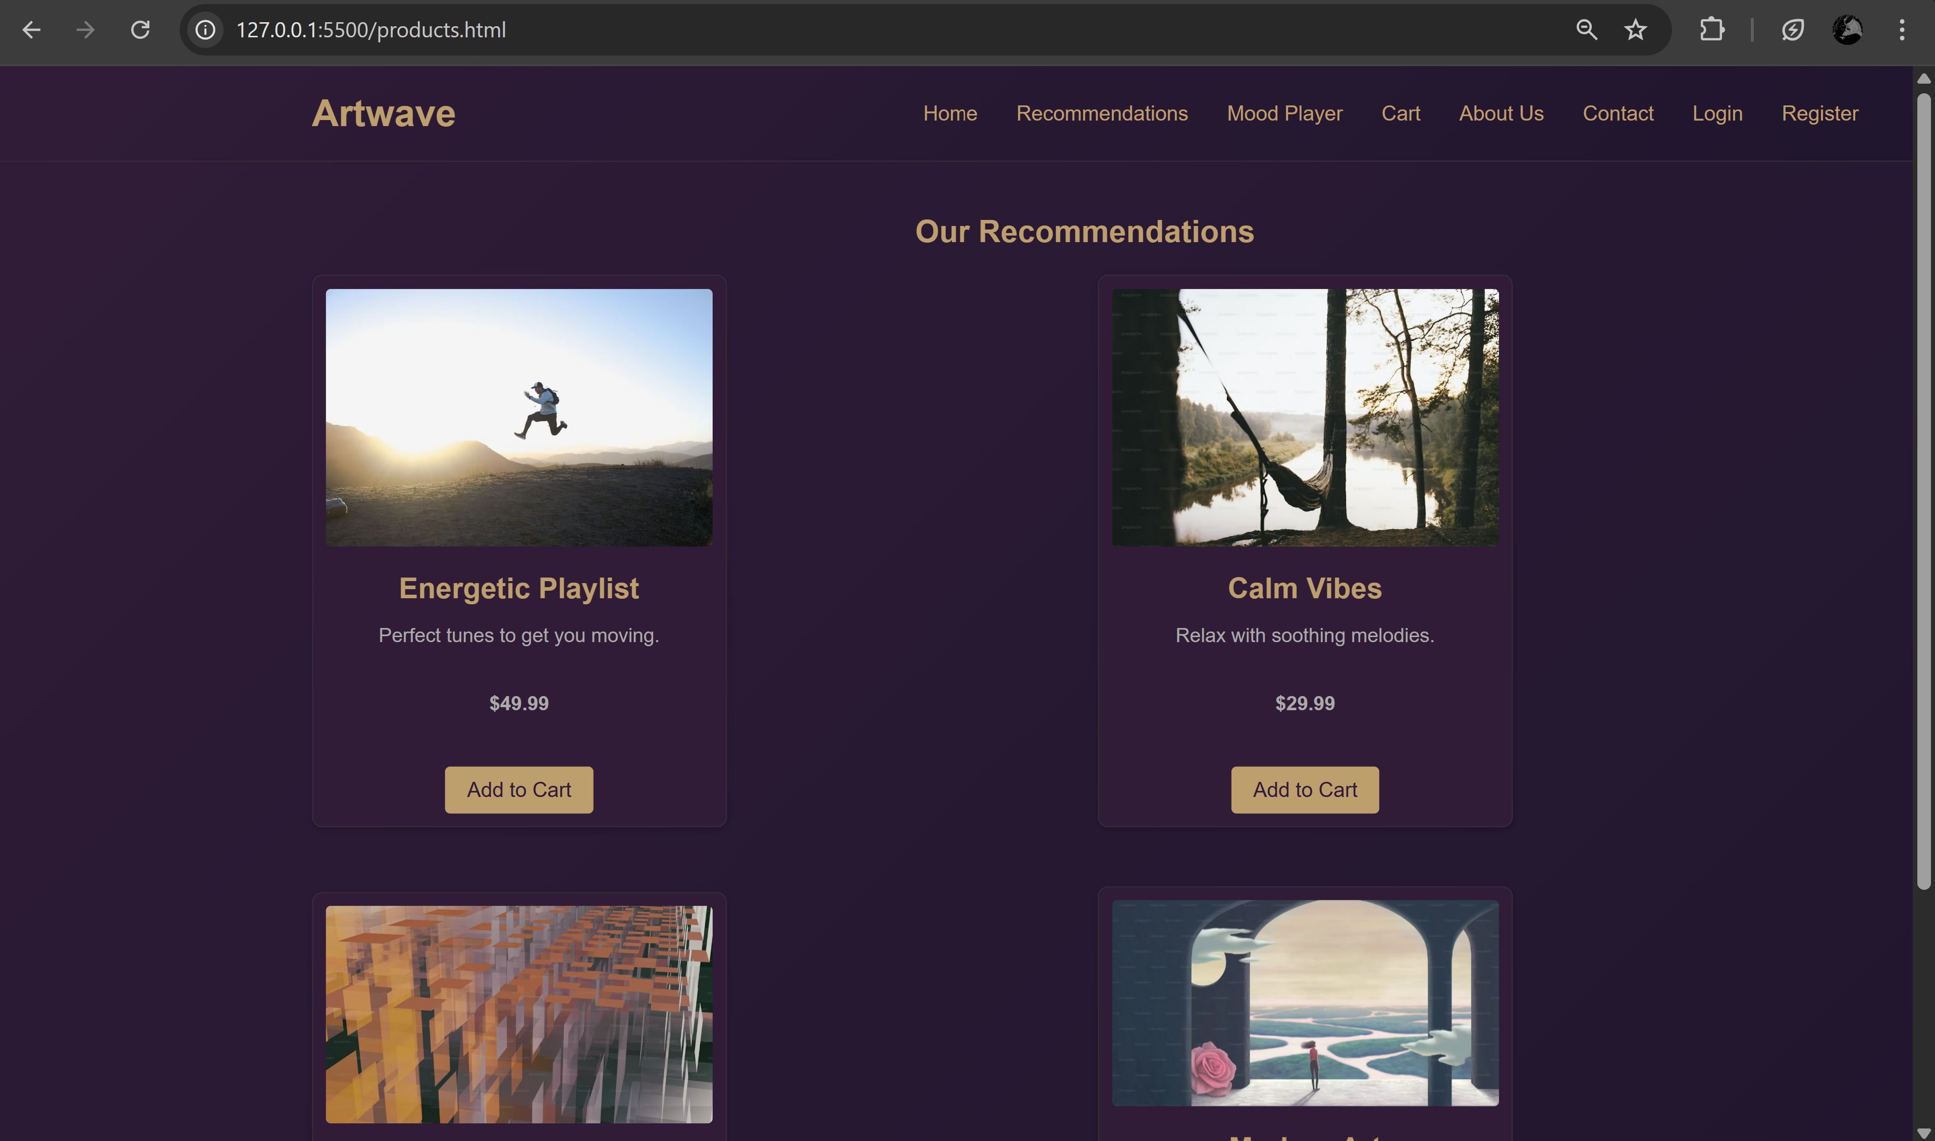

Cart.html page:-   
<!DOCTYPE html>

<html lang="en">

<head>

<meta charset="UTF-8">

<meta name="viewport" content="width=device-width, initial-scale=1">

<title>Artwave | Cart</title>

<link rel="stylesheet" href="style.css">

</head>

<body>

<header>

<div class="container header-container">

<div class="logo">Artwave</div>

<nav>

<ul>

<li><a href="index.html">Home</a></li>

<li><a href="products.html">Recommendations</a></li>

<li><a href="player.html">Mood Player</a></li>

<li><a href="cart.html">Cart</a></li>

<li><a href="about.html">About Us</a></li>

<li><a href="contact.html">Contact</a></li>

<li><a href="login.html">Login</a></li>

<li><a href="register.html">Register</a></li>

</ul>

</nav>

</div>

</header>

<section class="cart">

<div class="container">

<h2>Your Shopping Cart</h2>

<table class="cart-table">

<thead>

<tr>

<th>Item</th>

<th>Price</th>

<th>Qty</th>

<th>Total</th>

<th>Action</th>

</tr>

</thead>

<tbody>

<!-- Cart items will be dynamically inserted here -->

</tbody>

</table>

<div class="cart-summary">

<p><strong>Subtotal:</strong> $<span id="subtotal">0.00</span></p>

<a href="checkout.html" class="btn main-cta">Proceed to Checkout</a>

</div>

</div>

</section>

<footer>

<div class="container footer-content">

<p>&copy; 2025 Artwave. All Rights Reserved.</p>

<ul class="footer-links">

<li><a href="contact.html">Privacy Policy</a></li>

<li><a href="contact.html">Terms of Service</a></li>

</ul>

</div>

</footer>

<script>

document.addEventListener("DOMContentLoaded", function () {

const tbody = document.querySelector(".cart-table tbody");

const subtotalElem = document.getElementById("subtotal");

let cart = JSON.parse(localStorage.getItem("cartItems")) || [];

function renderCart() {

tbody.innerHTML = "";

let subtotal = 0;

if (cart.length === 0) {

tbody.innerHTML = "<tr><td colspan='5'>Your cart is empty.</td></tr>";

} else {

cart.forEach((item, index) => {

const price = parseFloat(item.price) || 0;

const qty = parseInt(item.qty) || 1;

const total = price * qty;

subtotal += total;

const tr = document.createElement("tr");

tr.innerHTML = `

<td>${item.title}</td>

<td>$${price.toFixed(2)}</td>

<td>

<input type="number" value="${qty}" min="1" data-index="${index}" class="qty-input">

</td>

<td>$${total.toFixed(2)}</td>

<td>

<a href="#" class="btn small-btn remove-btn" data-index="${index}">Remove</a>

</td>

`;

tbody.appendChild(tr);

});

}

subtotalElem.textContent = subtotal.toFixed(2);

attachEventListeners();

}

function attachEventListeners() {

document.querySelectorAll(".qty-input").forEach(input => {

input.addEventListener("change", function () {

const index = this.getAttribute("data-index");

let newQty = parseInt(this.value);

if (newQty < 1) newQty = 1;

cart[index].qty = newQty;

localStorage.setItem("cartItems", JSON.stringify(cart));

renderCart();

});

});

document.querySelectorAll(".remove-btn").forEach(btn => {

btn.addEventListener("click", function (e) {

e.preventDefault();

const index = this.getAttribute("data-index");

cart.splice(index, 1);

localStorage.setItem("cartItems", JSON.stringify(cart));

renderCart();

});

});

}

renderCart();

});

</script>

</body>

</html>

Cart output :-

